**CHARACTERISTIC OF TRANSISTOR**

**LAB # 09**



**Spring 2020**

**CSE-206 ELECTRONIC CIRCUIT LAB**

Submitted by: **Shah Raza**

Registration No: **18PWCSE1658**

Class Section: **B**

“On my honor, as a student of University of Engineering and Technology, I have neither given nor received unauthorized assistance on this academic work.”

Student Signature:

Submitted to:

**Engr. Abdullah Hamid**

Friday, August 14, 2020

Department of Computer Systems Engineering

University of Engineering and Technology, Peshawar

**OBJECTIVES:**

* To determine transistor type (npn, pnp), terminals and material using Digital multimeter.
* To determine the values of the alpha and beta ratios of transistors.

**EQUIPMENT:**

* Digital Multimeter (DMM)
* DC Power Supply

#### **COMPONENTS:**

* 1 kΩ Resistor
* 330 kΩ Resistor
* 10 kΩ potentiometer
* 1MΩ potentiometer
* 2N3904 Transistors

**THEORY:**

##### **TRANSISTOR:**

A transistor is a semiconductor device used to amplify or switch electronic signals and electrical power. It is composed of semiconductor material usually with at least three terminals for connection to an external circuit.

##### **BIPOLAR JUNCTION TRANSISTOR (BJT):**

Bipolar Junction Transistor (**BJT**) is a Semiconductor device constructed with three doped

Semiconductor Regions (Base, Collector and Emitter) separated by two p-n Junctions, Figure 1. The p-n Junction between the Base and the Emitter has a Barrier Voltage (V0) of about 0.6 V, which is an important parameter of a **BJT**.

A bipolar transistor is a semiconductor device consisting of three areas either P-type or N-type - an area of one type is sandwiched between areas of the other. The transistor fundamentally amplifies current but it can be connected in circuits designed to amplify voltage or power.

A bipolar transistor needs to be differentiated from a field effect transistor. A bipolar junction transistor, BJT, gains its name from the fact that it uses both holes and electrons in its operation. Field effect transistors are unipolar devices using one or either type of charge carrier.

A bipolar transistor, or more exactly a bipolar junction transistor, BJT, has two PN diode junctions which are back to back. The bipolar transistor has three terminals, named the emitter, base and collector.

The transistor amplifies current - bipolar transistors are current devices, unlike thermionic valves, vacuum tubes, and FETs which are voltage devices. The current flowing in the base circuit affects the current flowing between the collector and the emitter.

The relationships between the voltages and the currents associated with a BJT under various operating conditions determine its performance. These relationships are collectively kown as characteristics of the transistor.

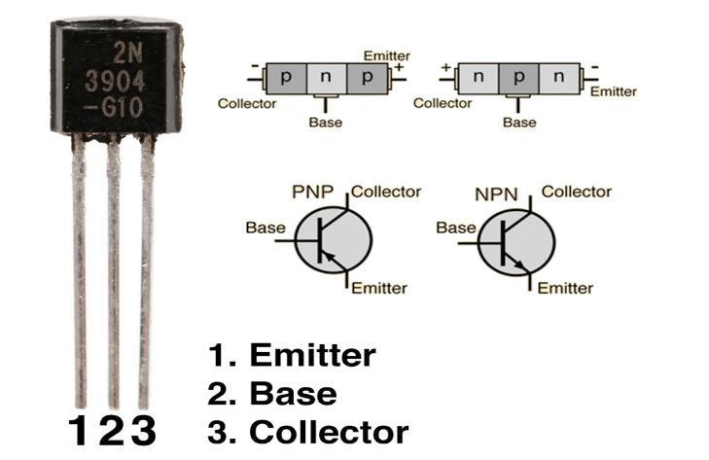

## **BASIC TRANSISTOR STRUCTURE:**

The transistor is a three terminal device and consists of three distinct layers. Two of them are doped to give one type of semiconductor and the three is the opposite type, i.e. two may be n-type and one p-type, or two may be p-type and one may be n-type. They are arranged so that the two similar layers of the transistor sandwich the layer of the opposite type. As a result, these semiconductor devices are designated as either PNP transistors or NPN transistors according to the way they are made up.

Basic structure and circuit symbols for NPN & PNP transistors

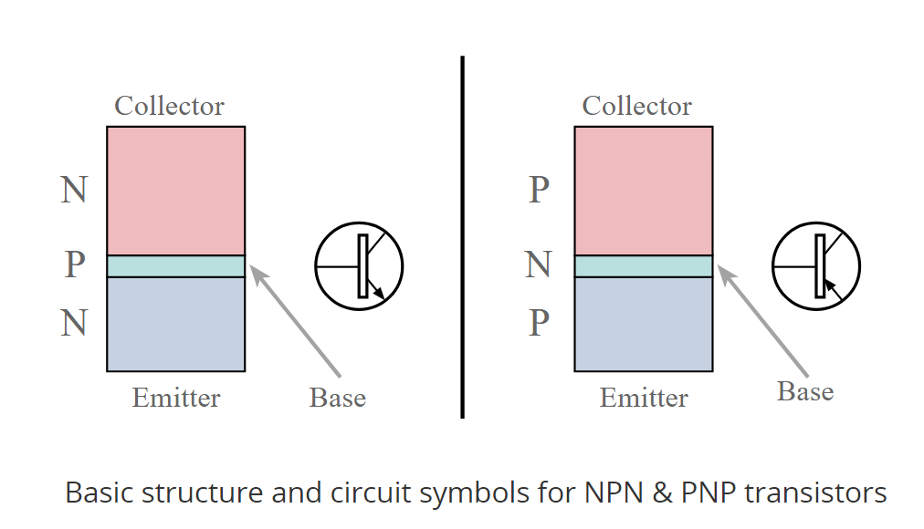

The names for the three electrodes widely used but their meanings are not always understood:

* ***Base:*** The base of the transistor gains its name from the fact that in early transistors, this electrode formed the base for the whole device. The earliest point contact transistors had two-point contacts placed onto the base material. This base material formed the base connection . . . and the name stuck.
* ***Emitter:***   The emitter gains its name from the fact that it emits the charge carriers.
* ***Collector:***   The collector gains its name from the fact that it collects the charge carriers.

For the operation of the transistor, it is essential that the base region is very thin. In today's transistors the base may typically be only about 1µm across. It is the fact that the base region of the transistor is thin that is the key to the operation of the device

**PROCEDURE:**

Construct the circuit of *Fig.1*. Vary the 1MΩ potentiometer to set IB = 10ΩA as in Table. 

1. Set the VCE to 2V by varying the 10kΩ potentiometer as required by the first line of Table
2. Record the VRC and VBE values in Table
3. Vary the 10 kΩpotentiometer to increase VCE from 2V to the values appearing in Table . (Note: IB should be maintained at 10ΩA for the range of VCE levels.)
4. Record VRC and VBE values for each of the measured VCE values. Use the mV range for VBE.
5. Repeat step 2 through 5 for all values of IB indicated in Table
6. Compute the values of IC (from IC = VRC/RC) and IE (from IE = IB+IC). Use measured resistor value for RC.

Compute the values of **α** (from **α** = IC/IE) and **β** (from **β** = IC/IB).

**RESULTS:**

|  |  |  |  |  |  |  |  |  |
| --- | --- | --- | --- | --- | --- | --- | --- | --- |
| **VRB (V)** | **IB (µA)** | **VCE (V)** | **VRC (V)** | **IC (mA)** | **VBE (V)** | **IE (mA)** | **α**= IC/IE | **β**= IC/IB |
| +3.3 | +10.1 | 1.26 | +2.44 | +2.44 | 0.7 | +2.45 | 0.995 | 0.241 |
| 6.67 | 20.3 | 0.21 | +2.74 | +2.74 | 0.7 | +2.76 | 0.992 | 0.134 |
| 9.99/10 | 30.5 | 0.19 | +2.75 | +2.75 | 0.7 | +2.78 | 0.989 | 0.09 |
| 13.2 | 40.1 | 0.18 | +2.75 | +2.75 | 0.7 | +2.79 | 0.985 | 0.068 |
| 16.6 | 50.3 | 0.17 | +2.75 | +2.75 | 0.7 | +2.80 | 0.982 | 0.054 |

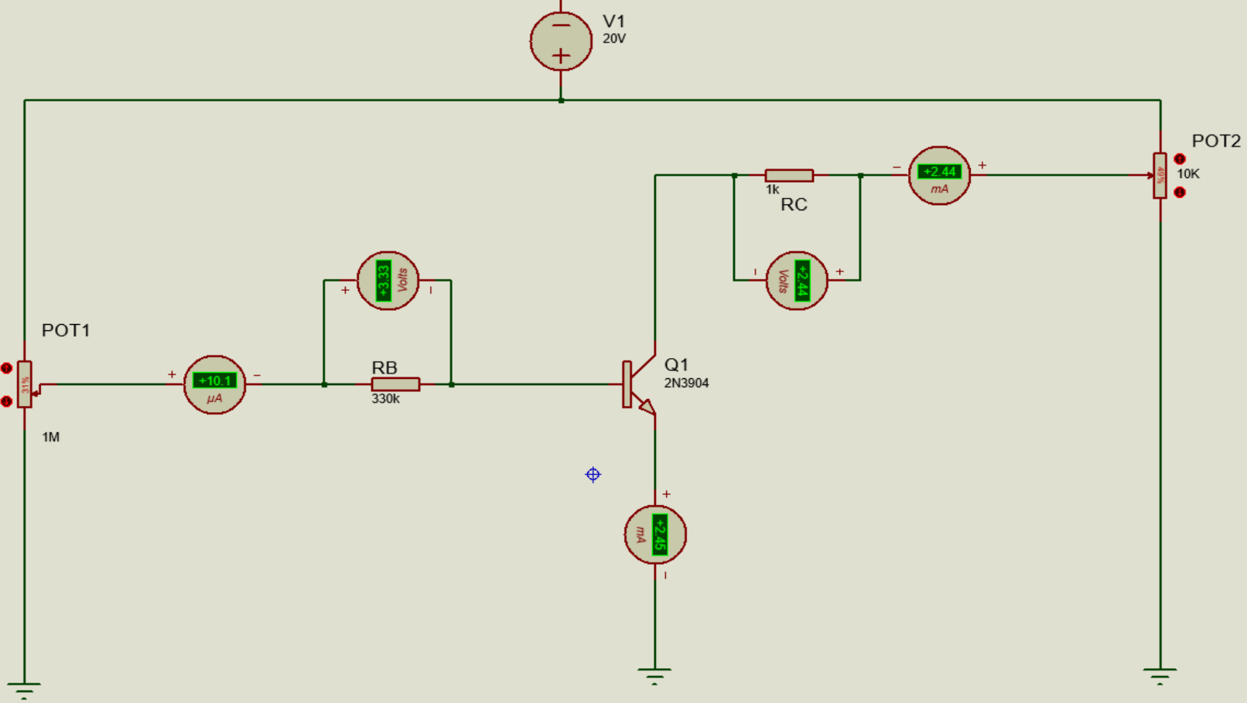

**SCHEMATIC DIAGRAMS:**

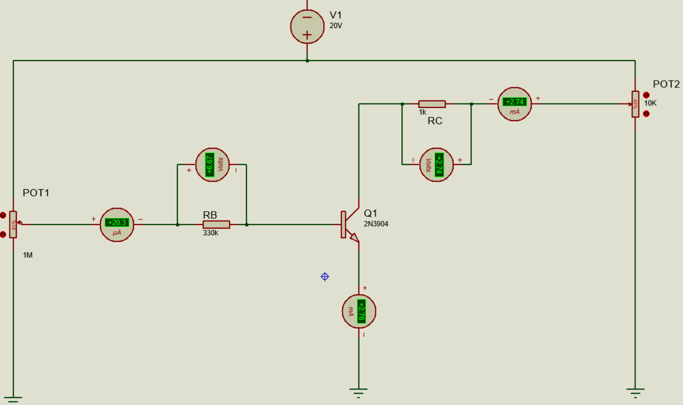

*When VRB=6.67, IB=20.3*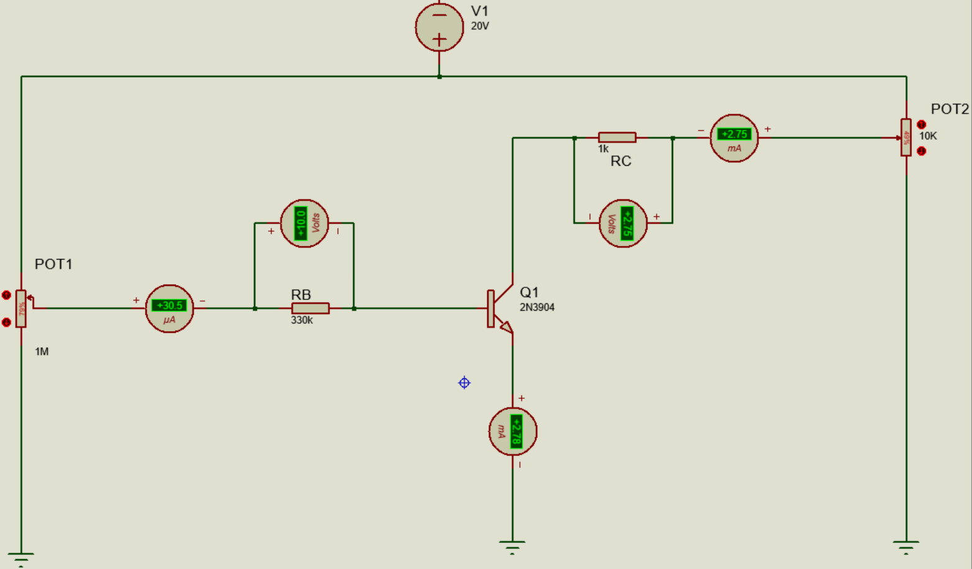

*When VRB=9.9, IB=30.5*

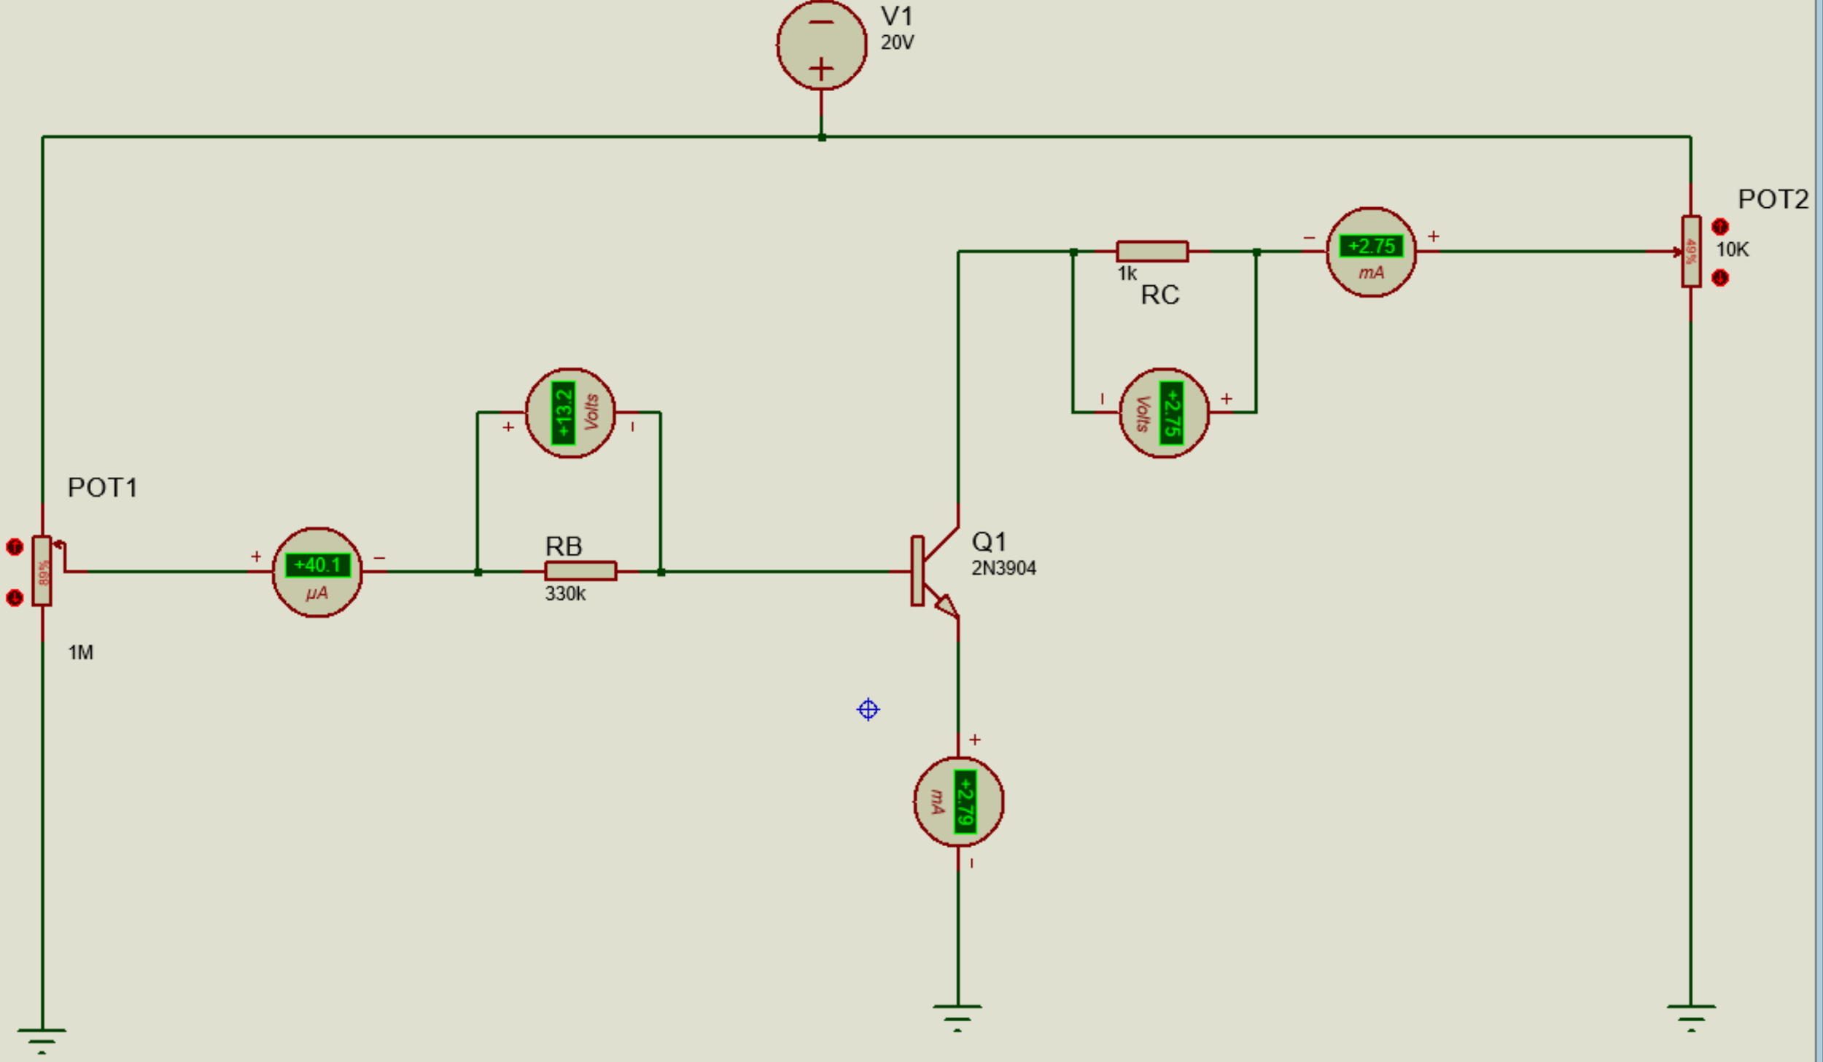

*When VRB=13.2, IB=40.1*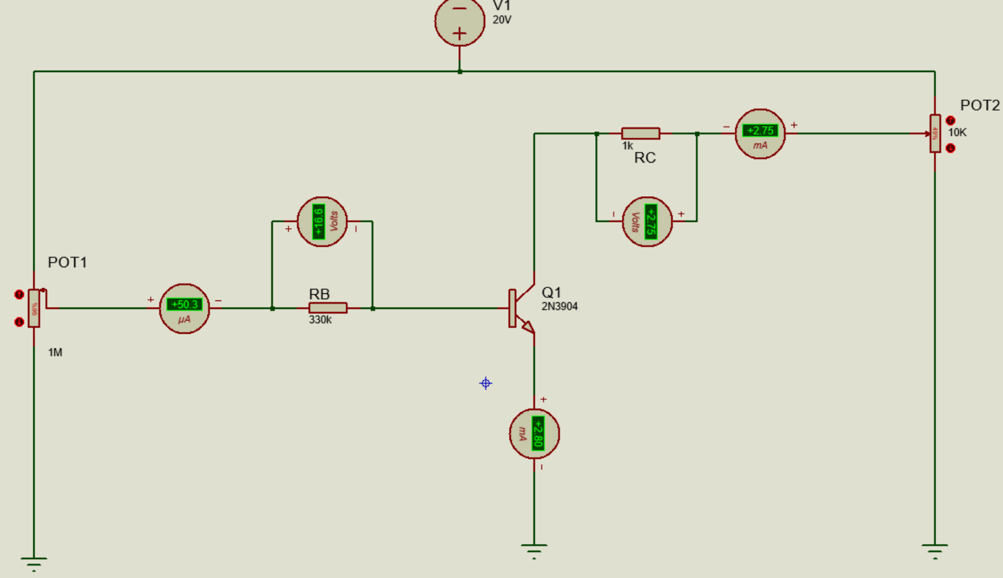

*When VRB=16.6, IB=50.3*